**Excel Assignment 4**

1. **What is the benefit of Microsoft 365?**

One of the main advantages of Office 365 is that it allows users to work from anywhere as long as they have internet connectivity. Because Office 365 is entirely cloud-based, emails, files, and popular Office programs (such as Word, PowerPoint, and Excel) can be accessed from any location and any device.

1. **Use two datasets and perform join on specific columns.**

If you are to merge two tables based on **one column**, VLOOKUP is the right function to use.

Supposing you have two tables in two different sheets: the main table contains the seller names and products, and the lookup table contains the names and amounts. You want to combine these two tables by matching data in the *Seller* column:  
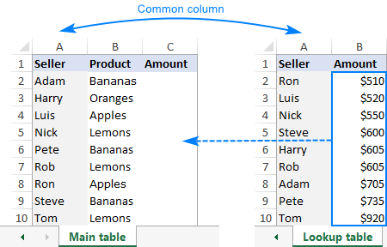

As you see, the order of the names in the main table does not correspond with that in the lookup table, therefore a simple copy/pasting technique won't work.

To combine two tables by a **matching column**(*Seller*), you enter this formula in C2 in the main table:

**=VLOOKUP($A2,'Lookup table'!$A$2:$B$10,2,FALSE)**

Where:

* *$A2* is the value you are looking for.
* *'Lookup table'!$A$2:$B$10* is the table to search (please pay attention that we lock the range with absolute cell references).
* *2* is the number of the column from which to retrieve the value.

Copy the formula down the column, and you will get a **merged table** consisting of the main table, plus the matched data pulled from the lookup table:  
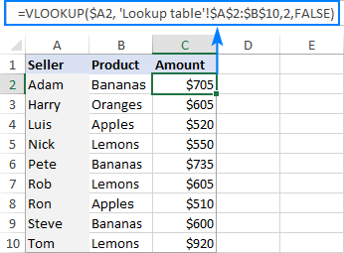

Please be aware that Excel VLOOKUP has several limitations, the most critical of which are 1) inability to pull data from a column to the left of the lookup column and 2) a hardcoded column number breaks a formula when you add or remove columns in the lookup table. On the bright side, you can easily reorder the returned columns simply by changing the number in the *col_index_num* argument.

1. **How to perform string formatting in excel. Demonstrate it with examples.**
2. Right-click any cell and select Format Cell.
3. On the Number format tab, select the formatting you need.
4. Select Custom from the Category list on the left of the Number Format dialog box.
5. Copy the syntax found in the Type input box.

1. **Create an advance expense distributor in excel.**

**Example: Consider expenses of a person who will be entered in excel at the same time expenses must be evenly distributed among all people with the amount of money each person should return/ receive.**

1. **Create reports to generate mark sheets of students in excel where percentages and addition of marks should be done using formulas**.

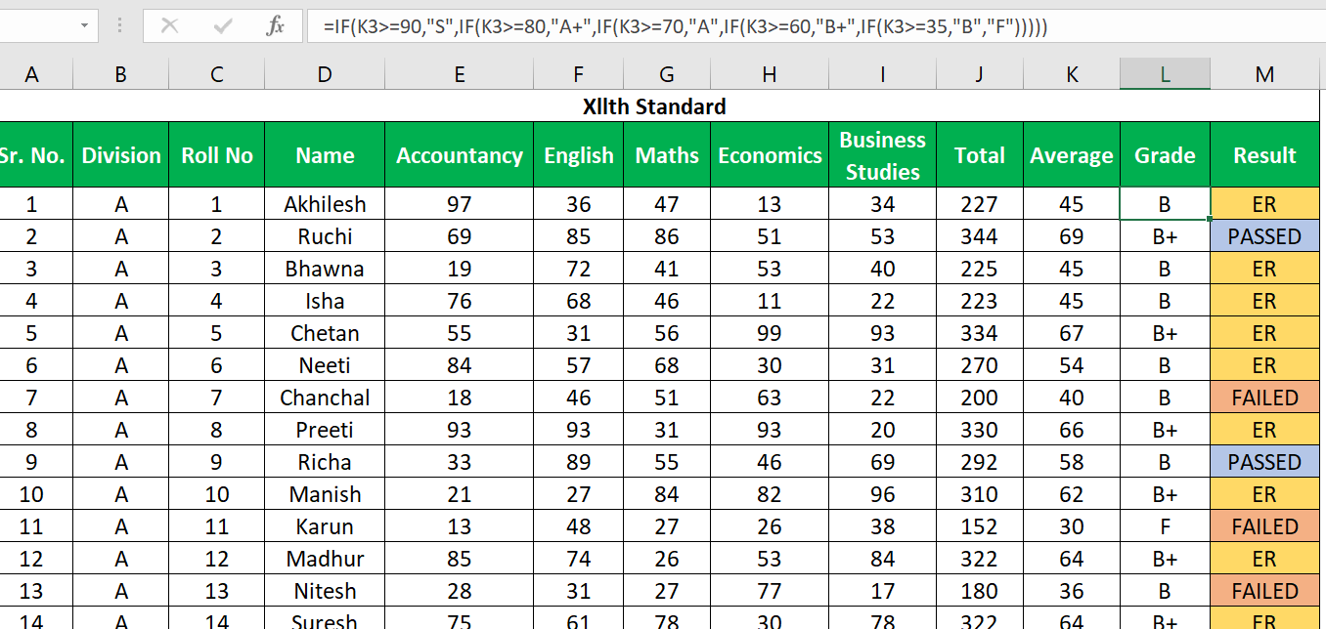s